**SOCIAL IMPACT**

**PLATFORM FOR THE LOCAL PEOPLES:**

Ashwat1, Dhanushree2, Kumaran3, Dinesh4, Noorul irfan5, Harshavardhini6

Dept.of Computer Science and Engineering

Dept.of Mechanical engineering,

KGISL Institute of Technology, Coimbatore, India

***Abstract :***

***The development of the application is for the local community which may serve a huge part in the lives of the rural people. This app makes easy for the people to manage, help, participate and volunteer in various social activities and needs of their local community. This application enables a great opportunity for the youngsters to actively engage themselves in volunteerism, and make themselves useful for the benefit of this society. It develops a meaningful interaction among the people about their needs and wants and regulates it. It increases the social reciprocity of the users.***

***Keywords:***

Communication, Rural people,Volunteerism, Meaningful interactions,Social reciprocity.

1. **INTRODUCTION:**

A social media platform is a platform that provides the ability to create social media websites and services with complete social media network functionality .It exhibits social media network technology and user specific characteristics.

They are divided into categories like social networking, social bookmarking, social news, media sharing, microblogging and online forums.

Social media started out as a way for people to interact with friends and family but soon expanded to serve many different purposes. They are online platforms that enable users to create and share content and participate in social networking. Now they are majorly used by youngsters and people who work in their respective online worlds.

The purpose of this social platform is to understand the role of local people and make a way for them to easily communicate with each other. More specifically this application make sure that the local community are aware of the events in their locality and encourage the practice of volunteerism among the young blood.

Each feature of this application is to ensure that the local people get to know more about their surrounding very well and communicate with them. The user can update the events that occurs around them in this platform. This is an age-friendly application. Mainly this platform is to share their respective problems and get a solution form the other.

2. **TECHNIQUES USED:**

i) Flask:

Python’s Flask is a lightweight framework for WSGI web applications. It is employed in route definition and web application creation.

ii) HTML and CSS:

The web application’s user interface is made with HTML and CSS. The page elements are structured using HTML. The styling of the HTML elements is done with CSS.

iii) MySQL:

MySQL is used to manage posts, comments, likes, shares, and other user interactions in addition to storing user data such usernames, passwords, email addresses, profile images, and other private information.

3. METHODOLOGY:

This project’s methodology includes meaningful communications, event calendar, regular news feed, collaboratory with NGO and other private organization.

3.1: Meaningful communications:

On a social impact platform designed with local communities in thoughts, relevant communication is essential to building participation and promoting change. Residents are informed about related initiatives, services, and activities using clear, compassionate messaging, which promotes involvement and cooperation.

Good two-way means of communication, such as social media, newsletters, and forums, encourage community discussion and feedback while making sure that all points of view are acknowledged and heard. Through emphasizing open and welcoming communication tactics, this kind of platform fosters a feeling of community and empowerment among users, which in turn drives group behaviour and increases the influence of neighbourhood-based initiatives.

3.2: Event calendar:

This Tkinter-based Python application generates a graphical user calendar. After letting users choose a year and month, it shows a calendar for that month. To add events, users simply click on any day in the calendar. These events are then stored and shown beneath the calendar. Based on user input, the script dynamically refreshes the events display and calendar. It has fields for the event name and time to be entered, and a save button to save the event. It also has the ability to clear previous events and update the display.

3.3 : Regular news feed :

By providing timely information on relevant events, projects, and opportunities, a social impact platform's regular RSS news feed strengthens local communities. This encourages participation, awareness, and cooperation among the community, which leads to positive change and increases the influence of neighbourhood initiatives for social improvement.

.

3.4: Colab with NGO and other private organization:

Through the facilitation of collaborations between NGOs, private organizations, and local communities, a collaborative platform for social impact may efficiently address community needs by pooling resources and expertise. Collaboration strengthens our potential to effect good change, advance sustainability, and raise the standard of living in our communities

**Social media platform for the local peoples:**



A community-focused application called "**Minvazhi**" was created to encourage communication and information sharing among users. It focuses mostly on local updates, including events, activities, and other pertinent information. With the help of the app, users can interact with others in their neighborhood, keep up with events happening nearby, and have conversations on a range of interesting subjects.

FEATURES:

. User profiles:

Users would fill in these with basic details about who they are, including name, interests, possibly a short bio.   
  
 . Chatting and message:

To encourage user interaction, the program probably has chat and message capabilities. Both group chats and private texting may fall under this category.

. information sharing:

Users would be able to share a variety of material, including links to articles or webpages, text entries.

. News Feed:

Users of the app would probably be able to view updates from the individuals and organizations they follow in this news feed. A variety of items, articles, and news updates, may be included in this feed.

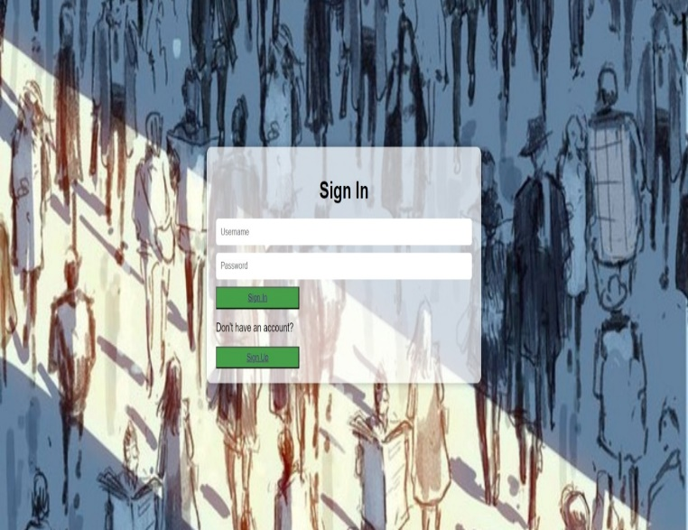

Step1: Look for the "Login" or "Sign In" option on the page. Click on it to proceed to the login page.

Step2 : On the login page, you'll see fields to enter your username and password. Input your credentials into the respective fields

**Step3:**

After entering your credentials, click on the "Login" or "Sign In" button to submit the information

**Step4**:

Otherwise,Click on the "Sign Up" or "Create Account" button to initiate the registration process

**Step5**:

Fill out the registration form with basic information such as name, email address, or mobile number.

**Step6**:

Once your credentials are verified, you'll be logged into your social media account. You should now have access to your news feed, messages, profile, and other features offered by the platform.

**CONCLUSION :**

In conclusion, creating a social impact platform specifically designed for a community may have revolutionary effects by encouraging community members to connect, work together, and feel empowered. Such a platform can operate as a catalyst for good change at the local level by utilizing technology to promote communication, resource sharing, and group action. With the use of technologies like resource directories, event planning tools, and community forums, locals can plan events, have meaningful conversations, and deal with urgent problems that impact their areas. Furthermore, via fostering equality, accessibility, and civic engagement, the platform possesses the capacity to amplify a range of perspectives, cross socioeconomic barriers, and foster a feeling of community ownership and belonging. In the end, a social impact platform's capacity to foster community relationships determines whether or not it is successful.

**REFERENCES:**

**1)** The Role of Social Media Content Format and Platform in Users’ Engagement Behaviorauthor:rebecca dolan, mona rashidiraddoi <https://doi.org/10.1016/j.intmar.2020.05.001>v

**2)** M. P. Lawton, “The impact of the environment on aging and behavior,” in Handbook of the Psychology of Aging, J. E. Birren and K. W. Schaie, Eds., pp. 276–301, Van Nostrand, 1977

**3)** A. E. Scharlach, “Creating aging-friendly communities,” Generations, vol. 33, no. 2, pp. 5–11,

2009.

**4)**P. H. Feldman, M. R. Oberlink, E. Simantov, and M. D. Gursen, “A Tale of two americas: community opportunities and challenges,” in Center for Home Care Policy and Research, Visiting Nurse Service of New York, New York, NY, USA, 2004.

**5)** The Importance of Social Connectedness in Building Age-Friendly Communication

author: Charles A. Emlet and Joane T. Moceri

doi <https://doi.org/10.1155/2012/173247>

**6)** Y. Sun, Y. Liu and J. Zhang, "Excessive Enterprise Social Media Use Behavior at Work: Role of Communication Visibility and Perspective of Uses and Gratifications Theory," in IEEE Access, vol. 8, pp. 190989-191004, 2020, keywords: {Social networking (online);Organizations;Sun;Media;Employment;Enterprise social media;communication visibility affordance;excessive use;perceived value;uses and gratifications theory},

**doi: 10.1109/ACCESS.2020.3032035.**

**7)** W. M. Alenazy, W. Mugahed Al-Rahmi and M. S. Khan, "Validation of TAM Model on Social Media Use for Collaborative Learning to Enhance Collaborative Authoring," in IEEE Access, vol. 7, pp. 71550-71562, 2019,.

keywords: {Social networking (online);Collaborative work;Collaboration;Education;Tools;Mathematical model;Adaptation models;TAM model;social media use;collaborative learning;collaborative authoring},

**doi: 10.1109/ACCESS.2019.2920242**